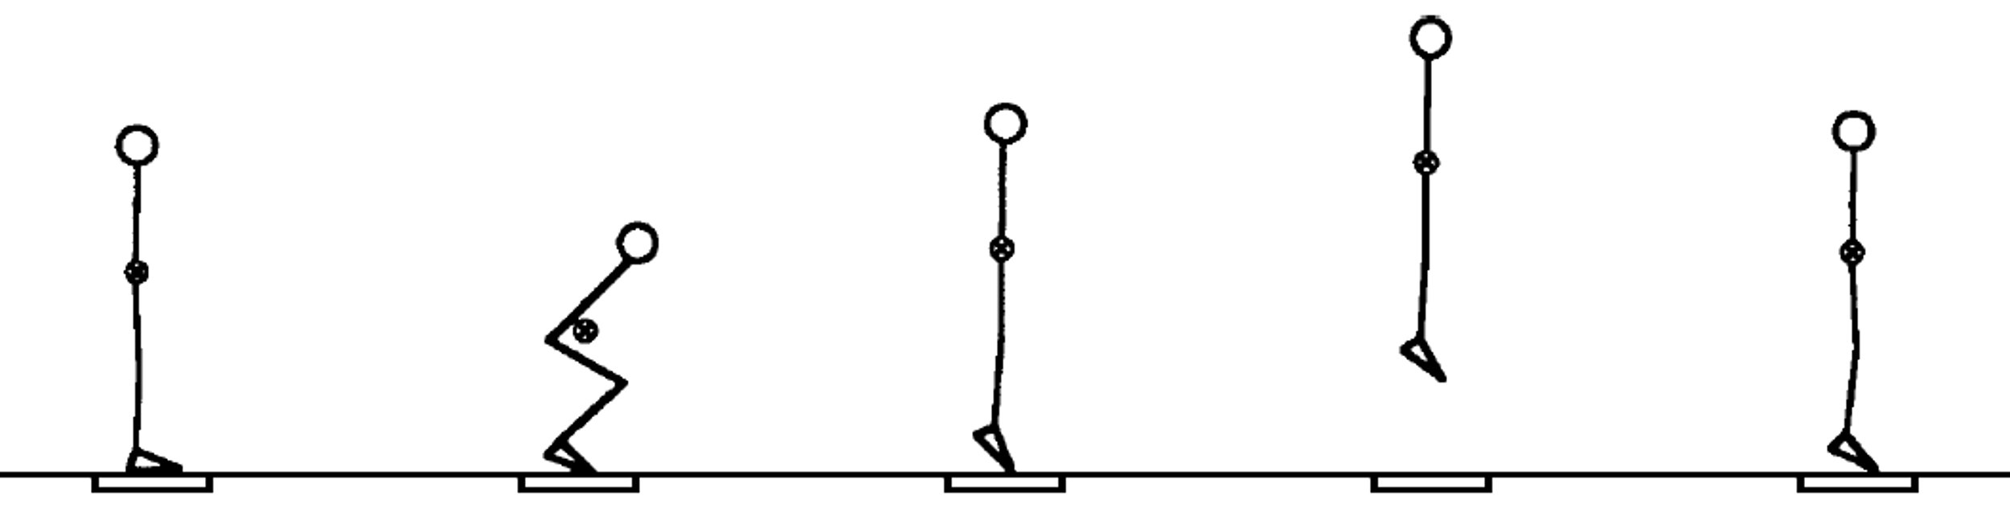  
(Linthorne, 2001)

# **Vertical Jump Height Worksheet – ‘International Jump Off’**

A maximum vertical jump is a standard test for measuring the power output of an athlete. There are many ways to measure this height, so today we will be using accelerometers to calculate it through the ‘time of flight’ and ‘double integration’ methods.

## **Time of Flight Method**

If you were to jump straight upwards, the length of time you are in the air can determine how high you have jumped.

**Activity:** Jump 3 times and get 3 people to time you during each jump. Record the results below.

Find the average time, and then use the height equation to predict how high you jumped.

$$\text{h = }\frac{\text{100}\text{g × }{\text{t}}^{\text{2}}}{\text{8}}$$

$$\text{h = 125 × }{\text{t}}^{\text{2}}$$

|  |  |  |  |
| --- | --- | --- | --- |
|  | Jump 1 | Jump 2 | Jump 3 |
| Timer 1 (s) |  |  |  |
| Timer 2 (s) |  |  |  |
| Timer 3 (s) |  |  |  |
| Average time (s) |  |  |  |
| My height prediction (cm) |  |  |  |
| Height (cm) |  |  |  |
| IMU’s prediction (cm) |  |  |  |

## **Double Integration Method**

You can also transform acceleration into displacement and find how high you have jumped.

~~This method is called double integration.~~

Acceleration  
↓  
Velocity  
↓  
Displacement

What is acceleration?  
______________________________________________________________________________________________________

What is velocity?  
______________________________________________________________________________________________________

What is displacement?  
______________________________________________________________________________________________________

What does the IMU predict the height of my jump(s) is?   
________________

Linthorne, N. P. (2001). Analysis of standing vertical jumps using a force platform. *Am. J. Phys., 69*(11), 1198-1204.